**Respiratory System – Notes**

Nasal cavity:

* 3 ridges of bone within the cavity increases the surface area.
* Contains cilia that increase the internal surface area.
* Large blood supply.
* Upper body has elongated cells with hair-like projections.

Function of the nasal cavity:

* Creates turbulence in the air – dust and particles are caught on the mucus membranes and nasal hairs.
* Air is warmed, moistened and filtered as it’s inspired.
* The upper part of the nasal cavity has specialized sensory cells (olfactory receptors) for the sense of smell.
* The nasal secretions contain an antibacterial enzyme called lysozyme.
* Acts to amplify the sounds of speech.

Pharynx – The region at the back of the mouth.

Function of the pharynx:

* Provides an air passage from the nasal cavity to the larynx and trachea.
* Provides a passage for food to pass through the throat to the oesophagus.

There are 3 regions of the pharynx:

1. Nasopharynx.
2. Oropharynx.
3. Laryngopharynx.

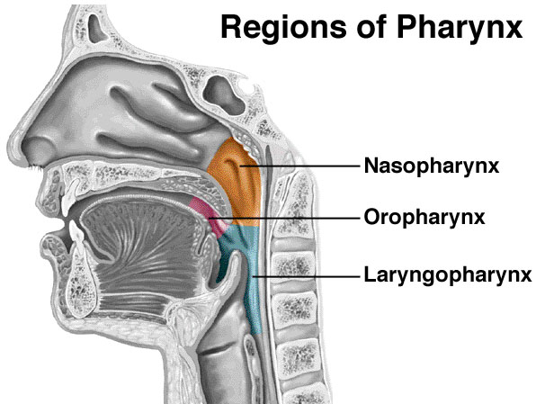

Epiglottis – A flap of cartilage.

Function of the epiglottis:

* Fits over the trachea when swallowing to prevent food from entering the trachea.

Larynx – Vocal cords supported by cartilage.

Function of the larynx:

* Sound production as air moves out of the lungs.

Trachea – The tube from the pharynx to the bronchi which is supported by C-shaped rings of cartilage.

Functions of the trachea:

* Carries air to and from the lungs.
* Cartilage holds the trachea open for air movement.
* Ciliated epithelium along its length cleans the air with mucus.
* Ciliated epithelium – Cilia beat rhythmically to remove mucus containing dust and foreign particles upwards towards the throat where it can be swallowed or coughed out of the throat.

Bronchi – The division of the trachea into 2 tubes which is composed of muscular walls and rings of cartilage. Cartilage plates are present with ciliated epithelium.

Functions of the bronchi:

* Air passage.

Bronchioles – Smaller tubes made up of smooth muscle that branch off each bronchi. At the end of each bronchiole many alveoli hang off them.

Alveoli:

* Consist of very flat epithelial tissue in direct contact with the blood supply for exchange of gases.
* Are very thin (one cell thick).
* Have a large surface area.
* Are moist.

Functions of the alveoli:

* Constant air flow keeps the necessary diffusion gradients for oxygen and carbon dioxide movement.
* Moisture enables diffusion because gases can only move into and out of blood when dissolved in fluid.
* Their location deep in the body minimizes evaporation of fluid off their surfaces.

The lungs are well-suited to their gas exchange function because:

* The alveoli give the lungs a huge internal surface area.
* Each alveolus is well-supplied with blood vessels.
* The membrane that forms the wall of the alveolus is very thin.
* The lungs are positioned deep inside the body to minimize evaporation of fluid.
* The lung volume can be changed by diffusion of the respiratory muscles.

Diffusion:

* Gases move into the capillaries by diffusion.
* The concentration of oxygen in the capillaries is less than the concentration of oxygen in the alveoli so the oxygen moves across the concentration gradient.

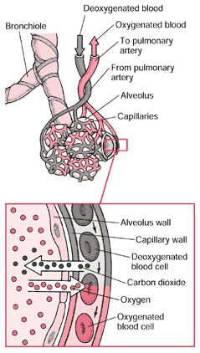

Pleura – The membrane covering the lung and the internal thoracic cavity.

Function of the pleura:

* The pleural membranes secrete pleural fluid which acts as a lubricant, preventing friction between the membranes as the lung moves within the thoracic cavity.
* The pleural fluid keeps the inner and outer layers in contact so that when the thorax moves, the lungs expand and contract.

Diaphragm – A sheet of muscle which separates the thoracic cavity from the abdominal cavity.

Function of the diaphragm:

* Aids in the ventilation of the lung.
* The diaphragm contracts to allow inspiration. When contracting and moving downward, there’s an increased lung volume.
* If the diaphragm is relaxed, it bulges into the thoracic cavity, causing air to move out of the lungs (expiration).

Intercostal muscles – Muscles found between the ribs.

Function of intercostal muscles:

* Aids in the movement of the ribs for the ventilation of the lungs.

Pathway of air through the respiratory system:

1. Nasal cavity.
2. Pharynx.
3. Larynx.
4. Trachea.
5. Bronchi.
6. Bronchioles.
7. Alveoli.
8. Capillaries.

1 🡪 8 = Inspiration.

8 🡪 1 = Expiration.

Breathing consists of 2 phases:

1. Inspiration – Inhalation: The process of taking in air.
2. Expiration – Exhalation: The process of blowing air out.

* The lungs expand and contract in response to changes in pressure inside the chest cavity.
* The diaphragm and intercostal muscles are the muscles that contract to create a greater volume in the thoracic cavity.
* The lungs don’t contain any muscles that change the volume of the lung.

Inspiration (inhaling):

* Intercostal muscles – Contraction moves the rib cage and sternum upwards and outwards. The width of the chest increases from side to side and front to back.
* Diaphragm – Contraction and lowering has the effect of increasing the internal volume of the chest, creating an area of low pressure.
* Air pressure and movement – Air from the outside (area of higher pressure) is drawn into the chest cavity (area of lower pressure).

Composition of inhaled air:

* 79% nitrogen.
* 20% oxygen.
* 0.04% carbon dioxide.

Composition of exhaled air:

* 79% nitrogen.
* 16% oxygen.
* 4% carbon dioxide.

External respiration:

|  |  |  |  |
| --- | --- | --- | --- |
|  | Partial pressure | (mmHg) |  |
|  | Alveolar sac: | Deoxygenated blood: | Oxygenated blood: |
| Oxygen | 100 | 40 | 100 |
| Carbon dioxide | 40 | 44 | 40 |

* Breathing maintains the correct concentration of gases in the lungs.

|  |  |  |
| --- | --- | --- |
|  | Inspiration | Expiration |
| Rib cage | Up and out | In and down |
| Diaphragm | Flattens | Bulges |
| Chest | Increase in volume | Decrease in volume |
| Lungs | Increase in volume | Decrease in volume |

**CHECK CIRCULATORY SYSTEM & RESPIRATORY SYSTEM – EXTENDED RESPONSE**

**Respiratory disorders**:

Lung cancer:

* Involves the development of a tumour – a mass of cells that divides in an uncontrolled way.
* The most common form of lung cancer begins in the walls of the air passages, usually the bronchi. Inhaled smoke particles constantly irritate the mucous membrane that lines the air passages. This results in excessive production of mucus and the accumulating mucus can’t be removed.
* The trapped mucus causes rupture of alveoli. Emphysema has been developed. Ultimately, a cancerous growth develops in an air passage and may spread to other parts of the body.

Pneumonia:

* Caused by bacteria, viruses, fungi or other organisms.
* The inflammation resulting from the infection causes secretion of fluid and mucus into the alveoli, thus reducing the amount of air that they can contain.
* The surface area available for gas exchange is reduced and breathing difficulty is a symptom for many types of pneumonia.
* Most living infections such as pneumonia are spread by droplets. When infected people cough, sneeze or spit, tiny droplets of moisture containing the bacteria, viruses or fungi may be inhaled by others, so spreading the infection.

Asthma:

* An allergic response to foreign substances that enter the body.
* During such an attack, the muscles that surround the bronchioles go into spasm – sudden involuntary contractions – which causes narrowing of the air passages and difficulty in breathing.
* Usually, the irritation of the membranes lining the air passages causes secretion of excessive mucus. This also restricts the movement of air.
* The reduced volume of air going into and out of the lungs means that the exchange of gases is impaired, and the blood doesn’t carry the usual amount of oxygen.

**Review Questions**

Characteristics of the lungs that make them well-suited for gas exchange:

* The alveoli give the lungs a huge internal surface area so that large amounts of gases can be exchanged in a relatively short time.
* Each alveolus is well supplied with blood vessels so that as much blood as possible is close to the air in the alveolus.
* Continuous flow of blood maintains a gas concentration difference between the air in the alveoli and the blood.
* The membrane that forms the wall of the alveolus is very thin, so that gas molecules do not have far to travel to move into or out of the blood.
* The lungs are positioned deep inside the body to prevent excessive evaporation of the fluid that covers the respiratory surfaces. It is important that the membrane of the alveolus be covered by a thin layer of moisture, because gases can diffuse into and out of the blood only when they are dissolved in fluid.
* Lung volume can be changed by respiratory muscles so that air is moved in and out of the lungs

Q: Why is it that in the lungs, oxygen diffuses into and carbon dioxide diffuses out of the blood, whereas in other body tissues oxygen diffuses out of and carbon dioxide into the blood?

Diffusion occurs because of differences in concentration. The concentration of oxygen in the air breathed in is higher than the concentration in the alveolar blood, so it diffuses from the air into the blood. The opposite is true of carbon dioxide. In the tissues, the concentration of oxygen is lower than in the blood, so oxygen diffuses from the blood into the cells. Again, the opposite is true for carbon dioxide, because the cell produces large amounts of carbon dioxide as waste from cellular respiration.

Q: Why is a concentration gradient important for the exchange of gases?

Movement of gases into and out of the blood occurs by diffusion, which can only occur when there is a concentration difference; gases diffuse from a region of higher concentration to one that is lower.

Q: Explain how a concentration gradient for oxygen and carbon dioxide is maintained between the blood and the air in the alveoli.

* Blood flows constantly through the capillaries. As the blood flowing through the capillaries around each alveolus picks up oxygen and loses carbon dioxide, it is replaced by more blood pumped into the capillaries. This ‘new’ blood is low in oxygen and high in carbon dioxide so that the concentration gradient is maintained.
* Air moves in and out of the alveoli as we breathe in and out. The air that has picked up carbon dioxide from, and lost oxygen to, the blood is replaced by ‘new’ air with each breath. The ‘new’ air is low in carbon dioxide and high in oxygen.

Q: Describe the types of lung damage that can be caused by smoking.

Smoke irritates the mucous membranes lining the air passages causing excessive production of mucus. Accumulating mucus can’t be removed, and the trapped mucus causes alveoli to rupture, resulting in emphysema. This reduces the surface area available for gas exchange so that breathing becomes difficult. Cancerous growths may develop in the lungs or air passages. Secondary tumours may occur in other parts of the body.

Q: Why does pneumonia cause difficulty in breathing?

Inflammation caused by pneumonia results in fluid being secreted into the alveoli. This reduces the amount of air the alveoli can contain so that the body cannot get enough oxygen to maintain normal body functioning.